**Lesson 2 Introduction of the Robotic Arm Driver Board**

**Table**

1. Appearance of Robotic Arm Driver Board 1

2. Overview 2

3. Introduction 3

4. Specification parameters of the main chip 5

4.1 ATmega328P Specification 5

4.2 CH340B Specification 8

4.3 LM1117 Specification 9

4.4 GS2678 Specification 10

5. Summaries 11

# Appearance of Robotic Arm Driver Board

**2D drawing**

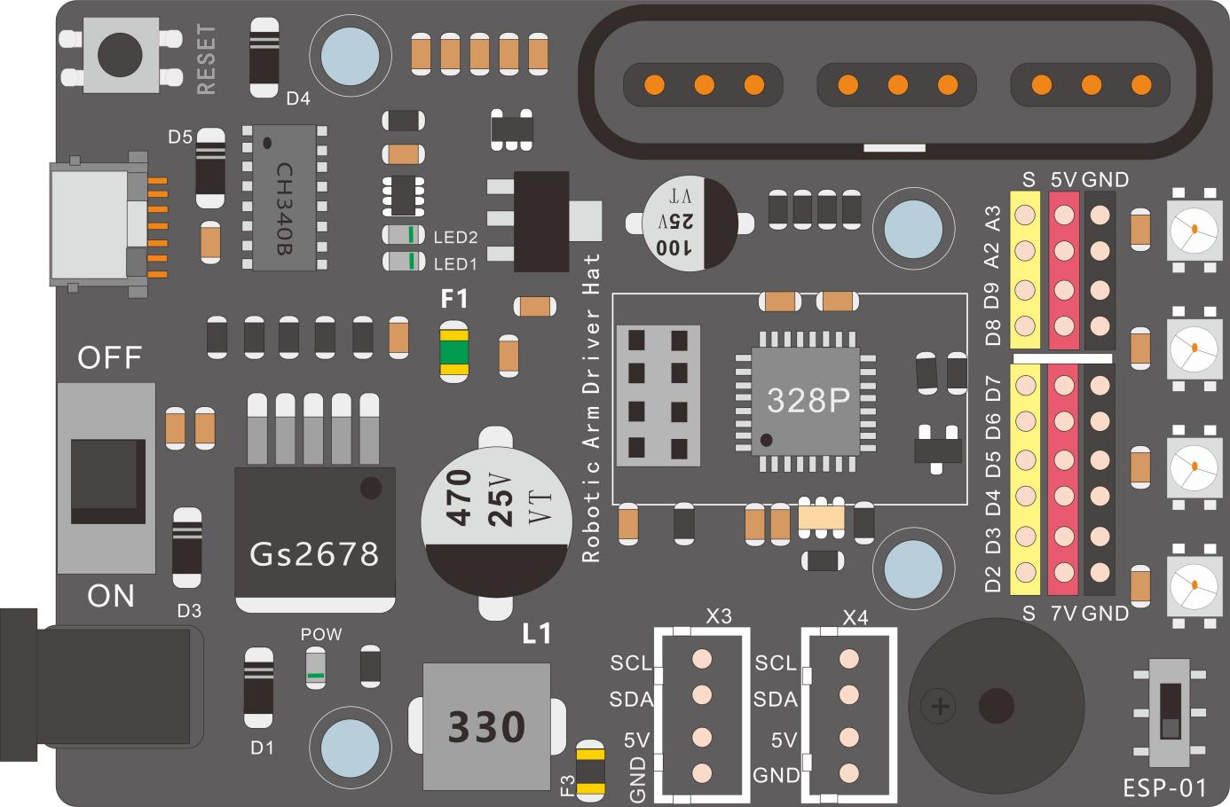

**3D Physical picture**

# Overview

This is a driver board specifically designed to drive Cokoino metal robotic arms, paired with Atemega328p main control chip, suitable for Arduino development environment. The main functional features are as follows:

1. Use the most popular type C USB interface, it is easier to plug and unplug.

2）Use CH340B USB to serial chip so that it can be compatible with various PC systems.

3）Use DC to DC 7V and DC to DC 5V power supply regulator system, make it not easy to heat up and save more power, and it can reach a maximum output 5A current.

4) Two I2C interfaces are reserved for external display screens or expansion of other I2C modules.

5) Use the PS2 interface to communicate with Atmega328p, making it convenient for the PS2 handle controller to control the operation of the robotic arm.

6) Designed 6 high-power servo signals, capable of withstanding a maximum output power of 7V/3A.

7) Mounted an active buzzer.

8) Mounted 4 WS2812 LEDs.

9) Reserved 4 I/O signals, which can be expanded to other functional modules.

10) Add an ESP8266 expansion interface, it can be connected to the ESP8266 module, to use WIFI control functions

# 3. Introduction

For the main components and functions of the Robotic Arm Driver Board, please refer to the following table.

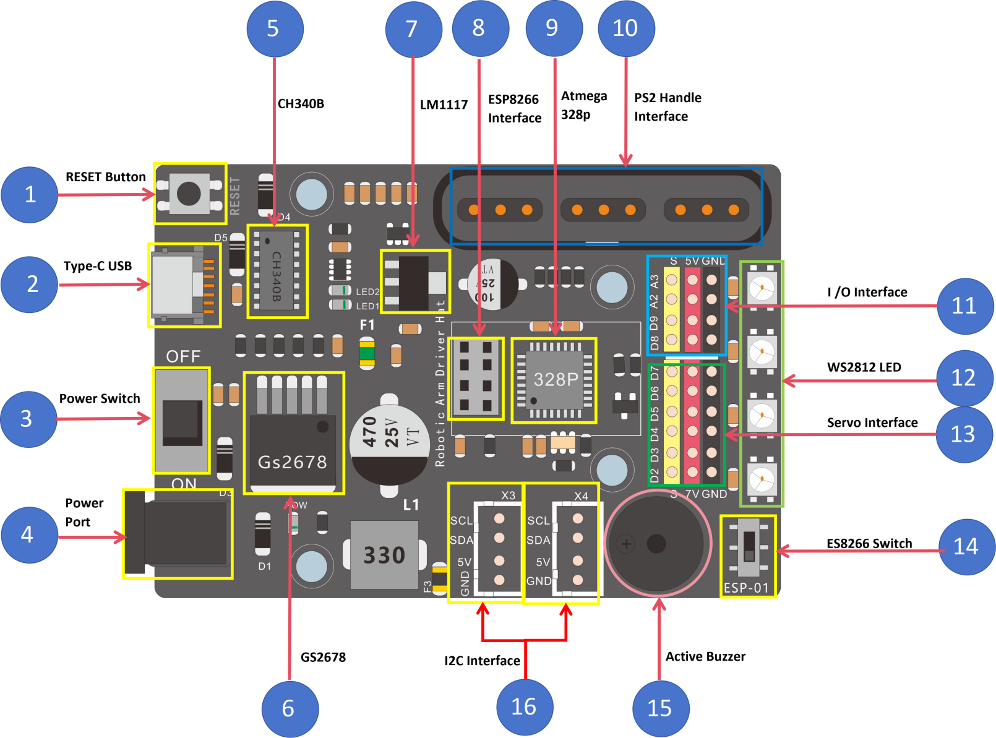

|  |  |  |
| --- | --- | --- |
| 1 | Reset button | The reset button of the system, press it to trigger the reset of the control board (reset the main control IC). |
| 2 | Type C USB Port | Burn the code on the IDE to the control board |
| 3 | Power Switch | Dial to ON to power on, dial to OFF to power off |
| 4 | Power Port | DC Power Port,power supply range: 7-12V DC. |
| 5 | USB to serial port system | The chip is CH340B, which enables the control board to communicate with the PC |
| 6 | 7V Voltage Regulator System | DC to DC 7V voltage regulator system to convert external power supply to DC7V |
| 7 | 5V Voltage Regulator System | DC to DC 5V voltage regulator system to convert external power supply to DC5V |
| 8 | ESP8266 Interface | Plug ESP8266 Module and reach ESP8266 function |
| 9 | Control IC | AteMega328P model, it is the core processor, just like the human brain, which handles receiving, sending, judging, interrupting, timing, driving and other events. |
| 10 | PS2 Handle Interface | Plug PS2 Handle,use PS2 Handle to control the Arm action |
| 11 | I/O Port | D8,The digital IO port of the Atemega328p |
| D9:The digital IO port of theAtemega328p, it is also used for the PWM output port (using timer1) |
| A2:Analog input port, it is also used for digital IO port |
| A3:Analog input port, it is also used for digital IO port |
| 12 | WS2812LED | Four WS2812 LEDs connected in series, occupying A1 (I/O PIN) of Atmega328p |
| 13 | IIC port | SDA：IIC data port (multifunction IO port, common pin with A4)  SCL：IIC clock port (multifunction IO port, common pin with A5) |
| 14 | Digital IO port | Digital IO port 2、4、7、8 of the control board |
| 15 | Buzzer | Occupy A0 IO Port of 328p chip |
| 16 | IIC port | SDA：IIC data port (multifunction IO port, common pin with A4)  SCL：IIC clock port (multifunction IO port, common pin with A5)  Used to expand I2C functionality |

# 4. Specification parameters of the main chip

## 4.1 ATmega328P Specification

Microcontroller：ATmega328P

Operating Voltage ：5V

Input Voltage (recommended)：6-12V

Input Voltage (limit)：6-18V（Is not recommended to use）

Digital I/O Pins：14 (of which 6 provide PWM output)

PWM Digital I/O Pins：6（D3, D5, D6, D9, D10, D11）

Analog Input Pins：6（A0~A7）

DC Current per I/O Pin ：20 mA

DC Current for 3.3V Pin：500mA

Flash Memory：32 KB (ATmega328P) of which 0.5 KB used by bootloader

SRAM：2 KB (ATmega328P)

EEPROM：1 KB (ATmega328P)

Clock Speed：16 MHz

LED_BUILTIN：13（IO）

size：69.5mm*55.0mm

Bootloader：UNO REV3

**Input and Output**

See the mapping between Arduino pins and ATmega328P ports. The mapping for the Atmega328 is identical.

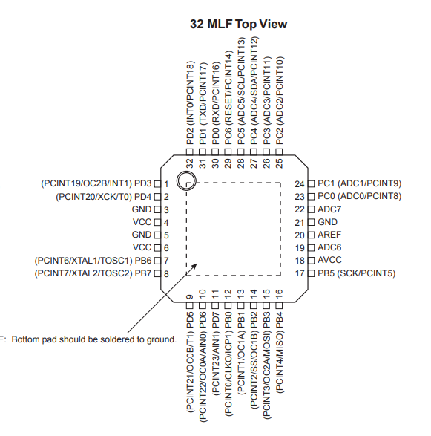

The idle digital pins on the control board can be used as an input or output, using pinMode(),digitalWrite(), and digitalRead() functions. They operate at 5 volts. Each pin can provide or receive 20 mA as recommended operating condition and has an internal pull-up resistor (disconnected by default) of 20-50k ohm. A maximum of 40mA is the value that must not be exceeded on any I/O pin to avoid permanent damage to the microcontroller.

## 4.2 CH340B Specification

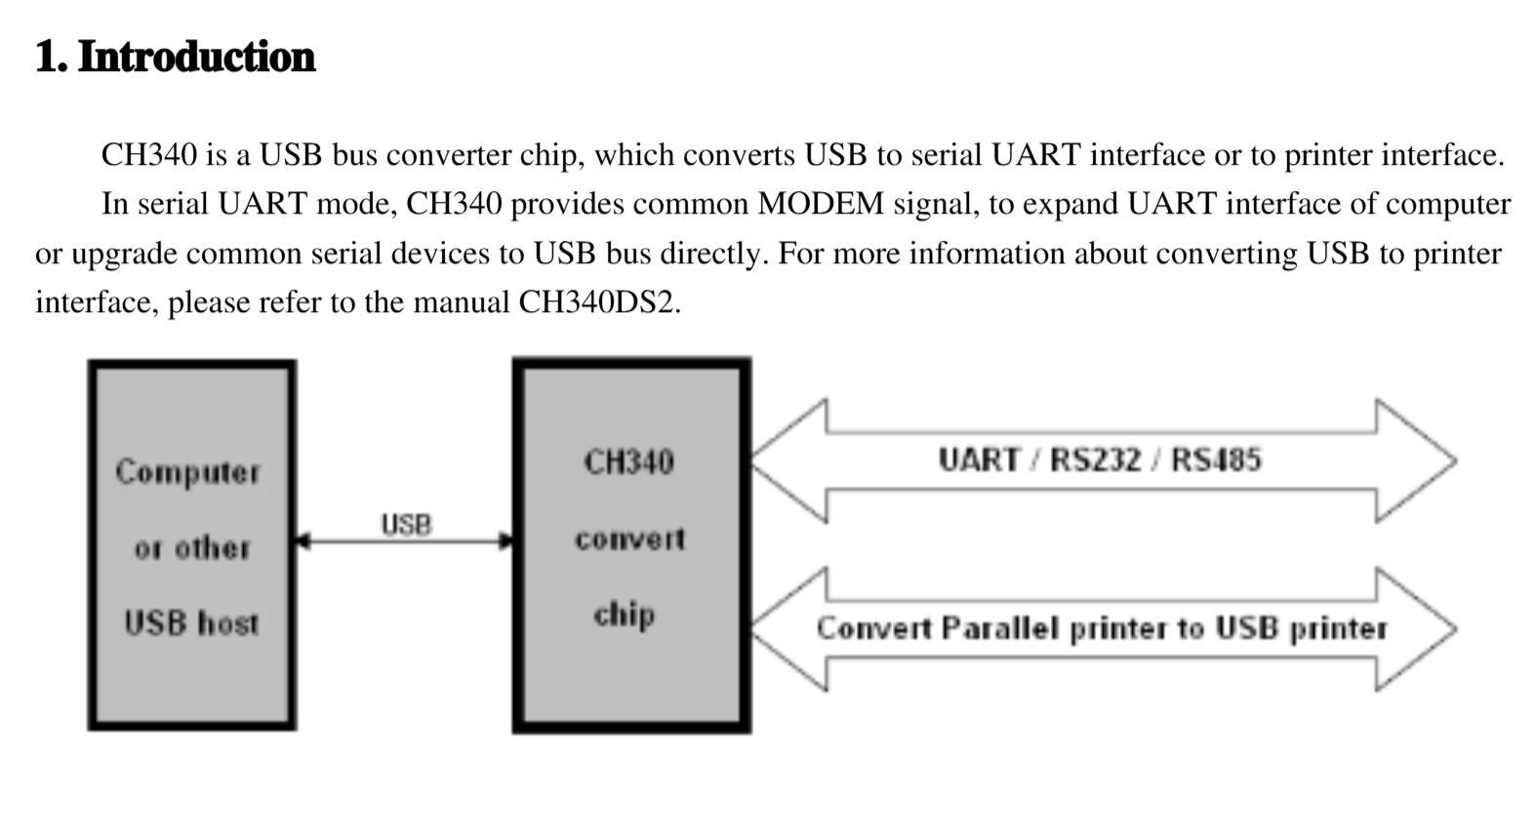

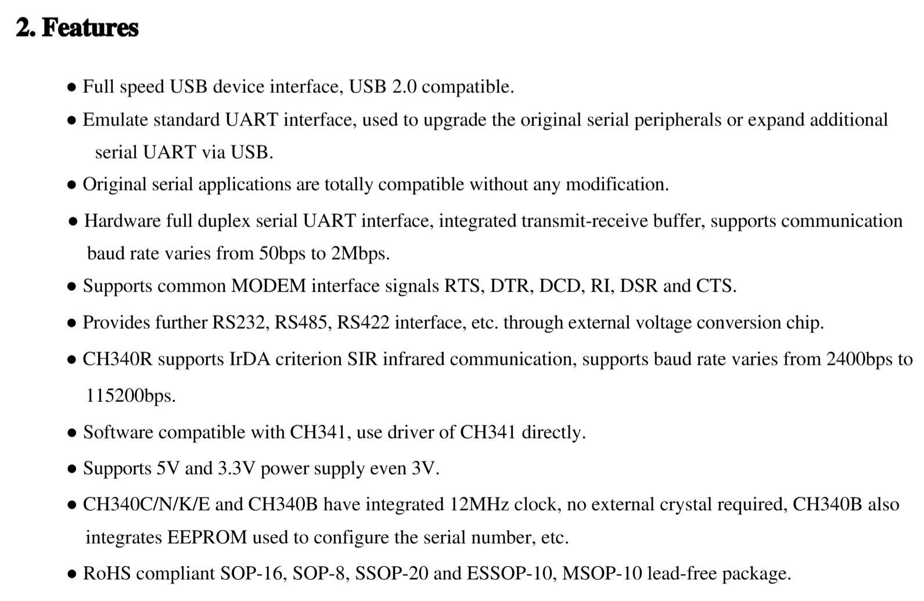

1. **Package**

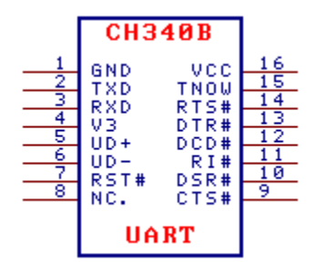

## 4.3 LM1117 Specification

**5 V FIXED POSITIVE LDO REGULATOR, 1.3 V DROPOUT, PSFM**

|  |  |
| --- | --- |
| Parameter | Attribute value |
| Minimum input voltage | 6.5 V |
| Maximum input voltage | 15 V |
| Number of functions | 1 |
| Number of terminals | 3 |
| Processing and packaging description | TO-220, 3 PIN |
| each_compli | Yes |
| Status | Active |
| Adjustment type | FIXED POSITIVE SINGLE OUTPUT LDO REGULATOR |
| Adjustable | FIXED |
| dropout_voltage1_nom | 1.2 V |
| Maximum voltage difference 1 | 1.3 V |
| input_voltage_absolute_max | 20 V |
| jesd_30_code | R-PSFM-T3 |
| jesd_609_code | e0 |
| line_regulation_max | 0.0100 V |
| load_regulation_max | 0.0150 V |
| moisture_sensitivity_level | 1 |
| Output number | 1 |
| erating_temperature,_tj_mi | 0.0 Cel |

## 4.4 GS2678 Specification

**5A 350KHz 25V Buck DC to DC Converter**

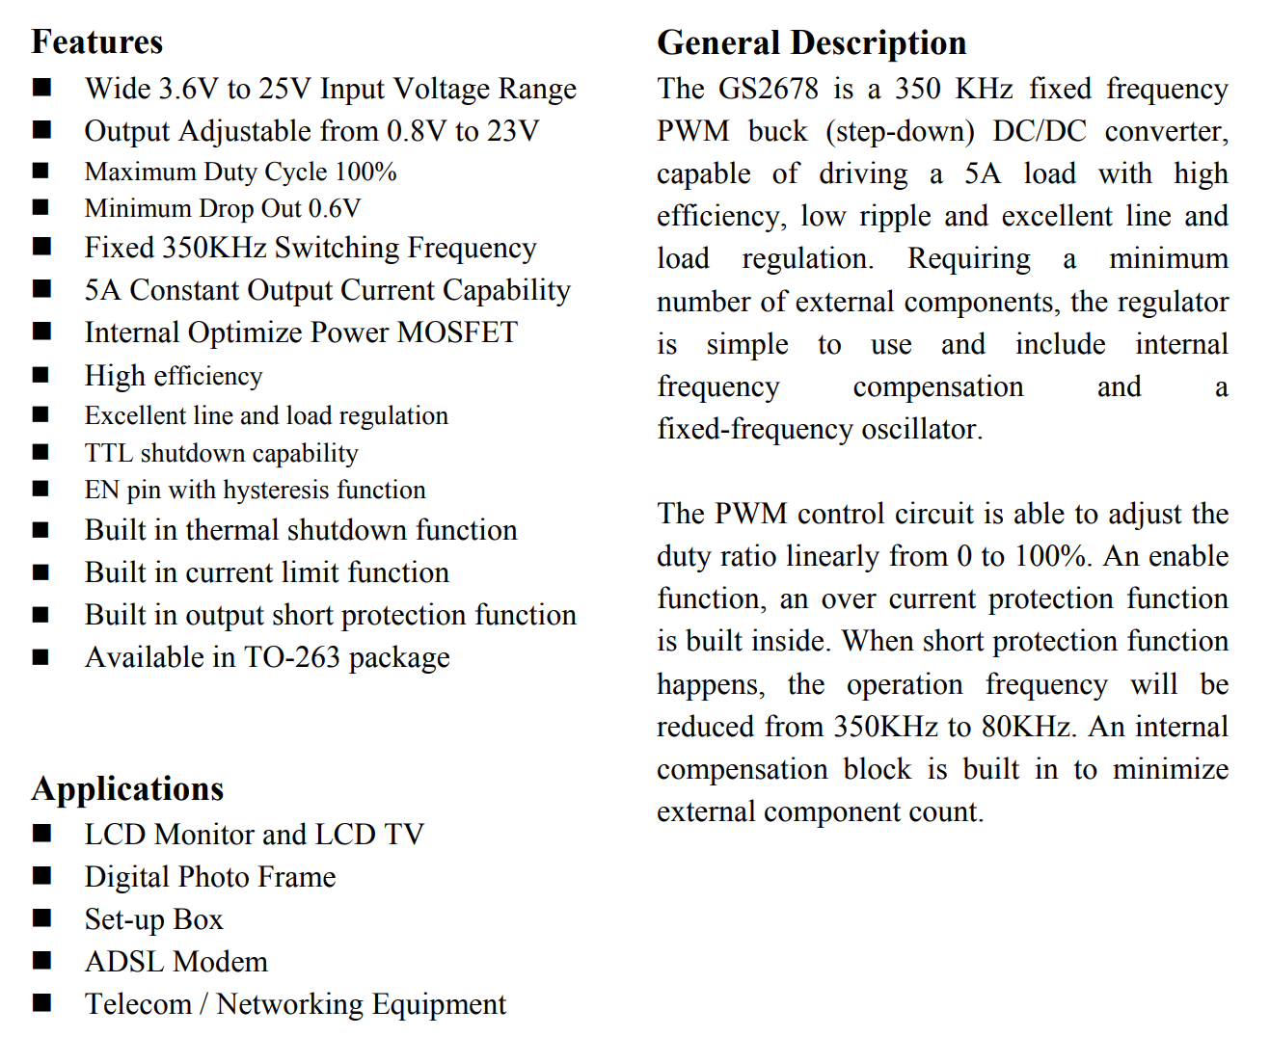

# Summaries

The Robot Control Board is very powerful, it not only has the function of Arduino UNO R3, but also expands the interface for infrared receiver, ESP8266 module, DRV8833 motor driver, PCA9685, etc.

It uses PCA9685 to expand 16 channels of signals, 8 channels are used for DRV8833 driving signals, and the other 8 channels of PWM signals are idle and can be connected to more modules.

You can use it to DIY more experiments, expand more functions, and help realize the ideas in your mind.